Approval of Personal Loans Through Logistic Regression Model
Allen Gao
University of Massachusetts Amherst
MIE622
Michael Prokle
To decide whether to approve a person’s loan application, the bank would review the applicant’s financial records and other relevant information to determine whether they are likely to repay the loan. The two possible outcomes, approve or reject, make this a binary classification problem. Logistic regression is an appropriate tool for helping the loan officer decide whether to approve the application because it can estimate the probability that the applicant will repay the loan.
The model was developed using the provided dataset to predict whether a loan would be approved and to evaluate its accuracy. The target variable is Personal Loan, which is binary. A value of 1 indicates the loan was approved, whereas a value of 0 indicates it was not. The other variables, such as age, having a credit card, having a mortgage, etc., are used as predictors to estimate the probability that a loan will be approved.
When the dataset was first loaded from the Excel file using the pandas library, it was first checked to make sure that there isn’t any missing data by checking if they have any question marks or recognizable missing values that are NaN. Once it was confirmed that no missing values remained, or that any missing values had been appropriately replaced, the dataset was checked for duplicate records. No duplicate rows were found, which means the dataset is all set to be split into a training and test dataset to be used for the Logistic Regression model.
The target variable, Personal Loan, was separated from the other variables and assigned to y as the outcome to be predicted. The remaining variables were assigned to the x variable as predictors, while the Zip Code, ID, and Age were excluded from it. ID is only a unique identification number assigned to each customer and does not describe the customer’s financial characteristics. ZIP Code represents geographic location rather than financial qualifications. Lastly, Age was excluded because it was strongly related to Experience, as older customers generally had more years of work experience. Therefore, the two variables contained overlapping information. Experience was retained because it more directly represented the customer’s employment background. Therefore, these variables were excluded because they were not meaningful predictors and could introduce noise or bias that negatively affects the model’s performance. Once the data were assigned to their respective variables, they were divided into training and testing sets using the train_test_split function. Seventy percent of the observations were used to train the Logistic Regression model, while the remaining 30% was used to evaluate its performance on unseen data. A random state of 42 was used so that the result would be reproducible if it were rerun.
Once the data were divided into training and testing sets, the Logistic Regression function from the sklearn.linear_model library was used to create and train the classification model. The model was fitted with training predictors and their corresponding target values to learn their relationship. Liblinear was selected as the solver because it was appropriate for binary classification, and a random state of 0 was used to make the model’s result reproducible. The model’s training accuracy was calculated using the score function with the training observations and their corresponding target values. After examining the training accuracy, a separate logistic regression model was fitted using the statsmodels library to evaluate the statistical significance and influence of the predictors. The coefficients were used to determine whether each variable had a positive or negative association with the target, while the p-values were used to identify the three most statistically significant variables. A new DataFrame was created to organize the coefficients and p-values for each predictor. The coefficients were used to determine the direction of each variable’s influence on the target outcome, while the p-values were used to evaluate statistical significance. Predictors with p-values below 0.05 were considered statistically significant. The results were then sorted from the smallest to the largest p-value, and the three predictors with the smallest p-values were selected as the most statistically significant variables. These predictors were displayed alongside their corresponding coefficients to show the direction of their influence on the target outcome, as shown in Figure A1.
To test the model with the test dataset, the predicted probabilities were generated by using the predict_proba function on the test predictors for approved personal loans. Two classification thresholds, 0.40 and 0.80, were then applied to compare the model’s performance at different probability cutoffs. The confusion matrix, classification report, and accuracy score were calculated for each threshold to examine how changing the cutoff affected the model’s false positives, false negatives, precision, recall, and overall accuracy.
In the results of using statsmodel’s Logistic Regression, it was able to show us that three significant predictors were CD Account, Experience, and Online, with the smallest p-value. CD Account had a positive coefficient, whereas Experience and Online had negative coefficients. The reason why CD Account has a positive coefficient is that customers who hold a certificate of deposit account have greater financial stability and more accumulated savings. These characteristics could make them more likely to qualify for or accept a personal loan. Experience had a negative coefficient, which suggests that customers with more work experience would be less likely to get a personal loan, as they may be more financially stable and therefore have less need for a personal loan. Lastly, online also had a negative coefficient, where those who have online banking facilities may be less likely to have personal loans. One possible explanation is that online-banking customers may have less direct interaction with bank employees and may therefore be less exposed or responsive to personal-loan promotions. However, this explanation is speculative.
Out of these 3 significant variables, it seems that the online variable is the most negative influence on loan acceptance. This could mean that customers who used online-banking services were less likely to have their personal loans approved than customers who did not use online banking. A possible explanation is that the bank may have required additional identity verification for online transactions because of the risk of fraud or someone impersonating the customer. As shown in Figure A2, the threshold of 0.40 achieved the higher test accuracy of the two thresholds. It produced an accuracy of approximately 95.2%, compared with approximately 93.0% for the 0.80 threshold. Therefore, the 0.40 threshold provided better overall classification performance on the test dataset. At the 0.40 threshold, the model achieved a precision of 96% for rejected loans represented by class 0, whereas it achieved a precision of 82% for approved loans represented by class 1. This indicates that the model was more precise when predicting loan rejection than when predicting loan approval. This may be due to the class imbalance of the model, as there are far more class 0 than class 1, which hurts the precision rate for class 1.
Overall, the logistic regression model performed well when predicting loan outcomes. It achieved a training accuracy of approximately 95.2% and a test accuracy of approximately 95.2% using the 0.40 threshold. The similarity between the training and test accuracies suggests that the model generalized reasonably well to unseen data. However, it predicted rejected loans more precisely than approved loans, partly because the dataset contained substantially more class-0 observations. The model may have been more reliable if the dataset had contained a more balanced distribution of class-0 and class-1 observations. Additional class-1 examples could have helped the model recognize approved loans more effectively and achieve a better balance between precision and recall. The logistic regression, however, is a useful tool to quickly decide whether or not the loans are approved or not.

Appendix
Figure A1
The Three Most Significant Predictors
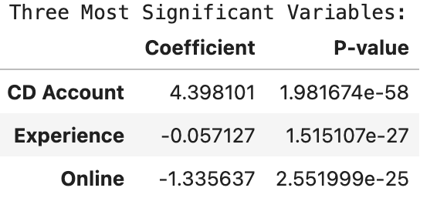
Note: Figure A1 shows the 3 predictors that are most significant to the model with their coefficients
Figure A2
Logistic Regression Test-Set Performance at Classification Thresholds of 0.4 and 0.8
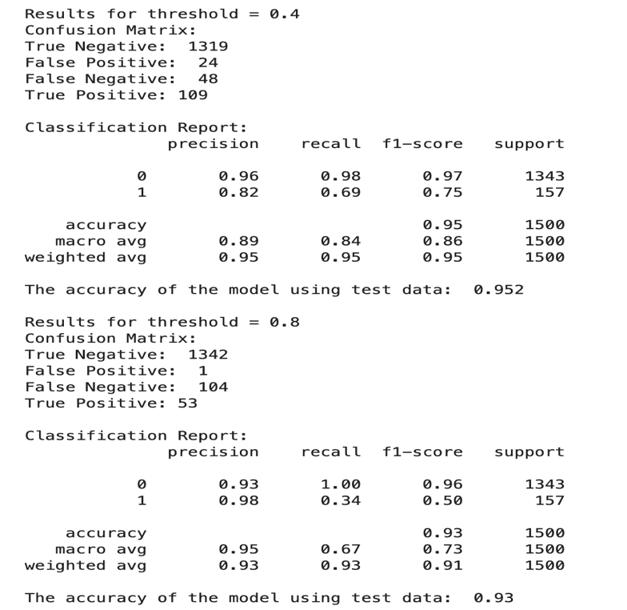
Note. The results were calculated using the test dataset. The 0.40 threshold achieved 95.2% accuracy, compared with 93% for the 0.80 threshold.

